CREATIVE EDUCATIONAL SERVICES
END OF TERM I EXAMINATIONS
ENGLISH
2024

NAME: ____________________________________________ MIDDLE CLASS

1. Fill in the missing letters.
a _____ c _____ e _____ g _____ i _____ k _____
m _____o _____q _____ s _____ u _____ w _____ y _____

2. Name these pictures.
 ______________________________
 ______________________________
 ______________________________
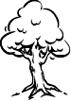 ______________________________

3. Read and draw
ball | mat | cat
bag | moon | sun
4. Find the missing parts
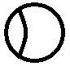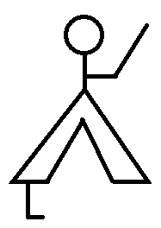
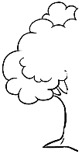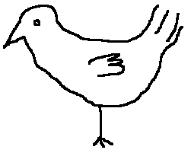

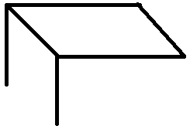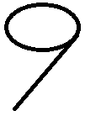
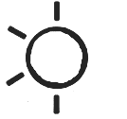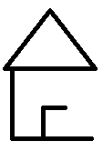

5. Fill the missing letters in words.
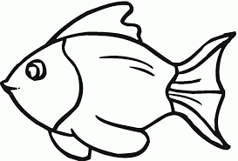 f __ sh | 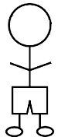 b __ y | 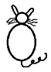 c __ t
p __ t | b __ x |  s __ n

6. Make sentences.
 | Here is a
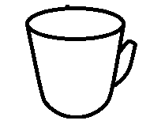
 | This is a
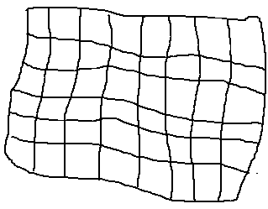
 | It is a
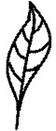

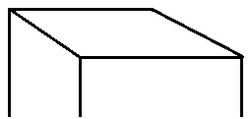 | That is a

End
***Good luck***

